CASE STUDY PYTHON
29-07-2025
1 . import pandas as pd
import numpy as np
import matplotlib.pyplot as plt
import seaborn as sns

2. df = pd.read_csv('LoanData (1).csv')

3. print(df.head()) # Displays the first few rows of the DataFrame
output:
Loan_ID Gender Married Dependents Education Self_Employed \
0 LP001002 Male No 0 Graduate No
1 LP001003 Male Yes 1 Graduate No
2 LP001005 Male Yes 0 Graduate Yes
3 LP001006 Male Yes 0 Not Graduate No
4 LP001008 Male No 0 Graduate No

ApplicantIncome CoapplicantIncome LoanAmount Loan_Amount_Term \
0 5849 0.0 NaN 360.0
1 4583 1508.0 128.0 360.0
2 3000 0.0 66.0 360.0
3 2583 2358.0 120.0 360.0
4 6000 0.0 141.0 360.0

Credit_History Property_Area Loan_Status
0 1.0 Urban Y
1 1.0 Rural N
2 1.0 Urban Y
3 1.0 Urban Y
4 1.0 Urban Y

4. # Check the shape of the dataset
print(df.shape)

# Display the first few rows
print(df.head())
output :
(614, 13)
Loan_ID Gender Married Dependents Education Self_Employed \
0 LP001002 Male No 0 Graduate No
1 LP001003 Male Yes 1 Graduate No
2 LP001005 Male Yes 0 Graduate Yes
3 LP001006 Male Yes 0 Not Graduate No
4 LP001008 Male No 0 Graduate No

ApplicantIncome CoapplicantIncome LoanAmount Loan_Amount_Term \
0 5849 0.0 NaN 360.0
1 4583 1508.0 128.0 360.0
2 3000 0.0 66.0 360.0
3 2583 2358.0 120.0 360.0
4 6000 0.0 141.0 360.0

Credit_History Property_Area Loan_Status
0 1.0 Urban Y
1 1.0 Rural N
2 1.0 Urban Y
3 1.0 Urban Y
4 1.0 Urban Y

5. # Check for missing values
print(df.isnull().sum())
output :
Loan_ID 0
Gender 13
Married 3
Dependents 15
Education 0
Self_Employed 32
ApplicantIncome 0
CoapplicantIncome 0
LoanAmount 22
Loan_Amount_Term 14
Credit_History 50
Property_Area 0
Loan_Status 0
dtype: int64

6. # Filling missing values for LoanAmount
df['LoanAmount'] = df['LoanAmount'].fillna(df['LoanAmount'].median())

# Filling missing values for Loan_Amount_Term
df['Loan_Amount_Term'] = df['Loan_Amount_Term'].fillna(df['Loan_Amount_Term'].mode()[0])

# Filling missing values for Credit_History
df['Credit_History'] = df['Credit_History'].fillna(1) # Most common value is 1

7. print(df.describe())
output:
ApplicantIncome CoapplicantIncome LoanAmount Loan_Amount_Term \
count 614.000000 614.000000 614.000000 614.000000
mean 5403.459283 1621.245798 145.752443 342.410423
std 6109.041673 2926.248369 84.107233 64.428629
min 150.000000 0.000000 9.000000 12.000000
25% 2877.500000 0.000000 100.250000 360.000000
50% 3812.500000 1188.500000 128.000000 360.000000
75% 5795.000000 2297.250000 164.750000 360.000000
max 81000.000000 41667.000000 700.000000 480.000000

Credit_History
count 614.000000
mean 0.855049
std 0.352339
min 0.000000
25% 1.000000
50% 1.000000
75% 1.000000
max 1.000000

8. import seaborn as sns
import matplotlib.pyplot as plt

# Example visualization
sns.countplot(x='LoanAmount', data=df)
plt.show()

output:
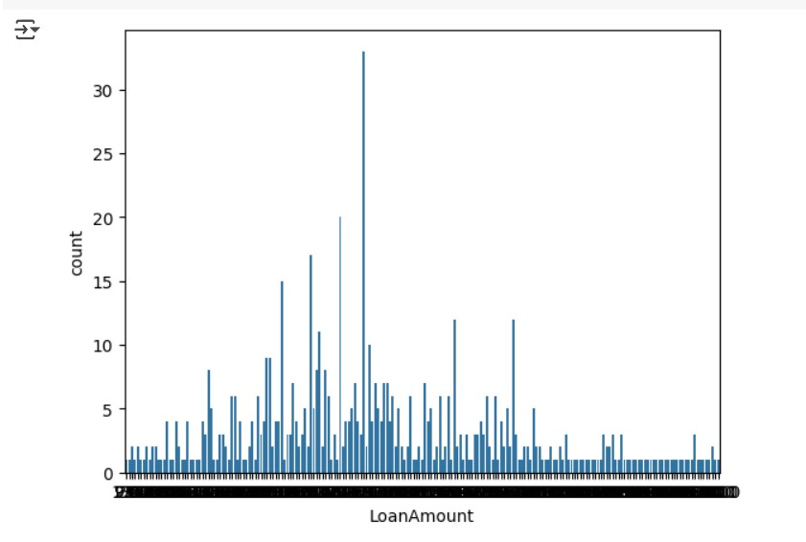
DATA PREPROCESSING
9.# Import necessary libraries
from sklearn.preprocessing import OneHotEncoder

# Create a OneHotEncoder instance
encoder = OneHotEncoder(drop='first', sparse_output=False) # Use sparse_output instead of sparse

# Select categorical columns to encode
categorical_cols = ['Gender', 'Married', 'Education', 'Self_Employed', 'Property_Area']

# Fit and transform the categorical columns
encoded_features = encoder.fit_transform(df[categorical_cols])

# Create a DataFrame from the encoded features
encoded_df = pd.DataFrame(encoded_features, columns=encoder.get_feature_names_out(categorical_cols))

# Drop original categorical columns and concatenate the new encoded DataFrame
df = df.drop(categorical_cols, axis=1)
df = pd.concat([df, encoded_df], axis=1)
NO OUTPUT

b)from sklearn.preprocessing import StandardScaler

# Initialize the scaler
scaler = StandardScaler()

# Select numerical columns to scale
numerical_cols = ['ApplicantIncome', 'CoapplicantIncome', 'LoanAmount']

# Scale the numerical features
df[numerical_cols] = scaler.fit_transform(df[numerical_cols])
NO OUTPUT

EXPLORATORY DATA ANALYSIS (EDA)
import seaborn as sns
import matplotlib.pyplot as plt

# Drop non-numeric columns (e.g., Loan_ID)
df_numeric = df.select_dtypes(include=['float64', 'int64'])

# Correlation heatmap
plt.figure(figsize=(10, 6))
sns.heatmap(df_numeric.corr(), annot=True, fmt=".2f", cmap='coolwarm')
plt.title('Correlation Heatmap')
plt.show()
OUTPUT:
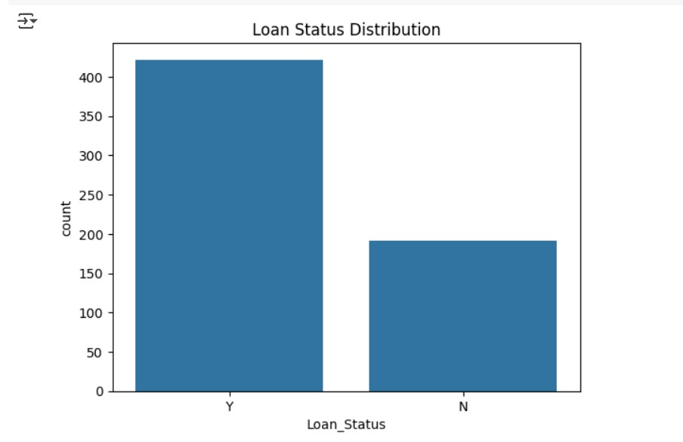
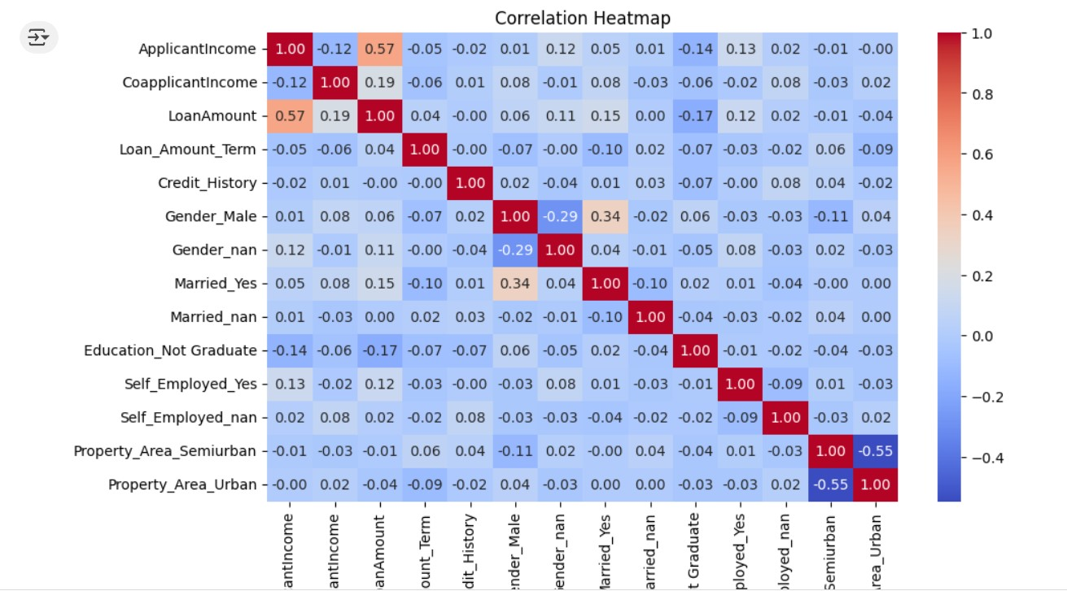

MODEL BUILDING
from sklearn.model_selection import train_test_split

# Define features and target variable
X = df.drop('Loan_Status', axis=1)
y = df['Loan_Status'].map({'Y': 1, 'N': 0}) # Convert Loan_Status to binary

# Split the dataset into training and testing sets
X_train, X_test, y_train, y_test = train_test_split(X, y, test_size=0.2, random_state=42)
NO OUTPUT

11. # Convert 'Dependents' to numeric after replacing values
X_train['Dependents'] = X_train['Dependents'].replace({'0': 0, '1': 1, '2': 2, '3+': 3}).astype(float)

# Now you can train the model
model.fit(X_train, y_train)

OUTPUT:
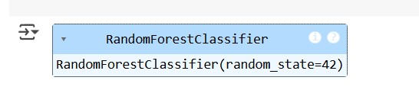

MODEL EVALUATION
Performance Metrics

from sklearn.ensemble import RandomForestClassifier

# Initialize the model
model = RandomForestClassifier(random_state=42)

# Replace and convert 'Dependents' to numeric
X_train['Dependents'] = X_train['Dependents'].replace({'0': 0, '1': 1, '2': 2, '3+': 3}).astype(float)

# Train the model using the existing X_train and y_train
model.fit(X_train, y_train)

# Optionally, you can print the model's feature importances
print("Feature importances:", model.feature_importances_)

OUTPUT:
Feature importances: [5.50629308e-02 1.99081025e-01 1.08024181e-01 1.81769477e-01
5.08332462e-02 2.41528548e-01 2.11506819e-02 8.32376687e-03
2.63166992e-02 1.32363219e-04 2.41972732e-02 1.86704258e-02
1.14368602e-02 3.31012357e-02 2.03712848e-02]

FINAL CODE AS A WHOLE WITH HYPERPARAMETER TUNING
# ============== 1. IMPORTS & SETUP ==============
import pandas as pd
import numpy as np
from sklearn.ensemble import RandomForestClassifier
from sklearn.model_selection import train_test_split, GridSearchCV
from sklearn.metrics import classification_report, confusion_matrix
from sklearn.preprocessing import OneHotEncoder
import seaborn as sns
import matplotlib.pyplot as plt
from flask import Flask, request, jsonify

# ============== 2. DATA PREPROCESSING ==============
# Load data
df = pd.read_csv('LoanData (1).csv')

# Handle missing values (example)
df['LoanAmount'] = df['LoanAmount'].fillna(df['LoanAmount'].median())
df['Credit_History'] = df['Credit_History'].fillna(1)

# Encode categorical variables
encoder = OneHotEncoder(drop='first', sparse_output=False)
categorical_cols = ['Gender', 'Married', 'Education', 'Self_Employed', 'Property_Area']
encoded_features = encoder.fit_transform(df[categorical_cols])
encoded_df = pd.DataFrame(encoded_features, columns=encoder.get_feature_names_out(categorical_cols))
df = pd.concat([df.drop(categorical_cols, axis=1), encoded_df], axis=1)

# Convert 'Dependents' to numeric
df['Dependents'] = df['Dependents'].replace({'0':0, '1':1, '2':2, '3+':3}).astype(float)

# Drop Loan_ID before splitting
df = df.drop(['Loan_ID'], axis=1, errors='ignore')

# Split data
X = df.drop(['Loan_Status'], axis=1) # Ensure Loan_Status is the only target variable
y = df['Loan_Status'].map({'Y':1, 'N':0})
X_train, X_test, y_train, y_test = train_test_split(X, y, test_size=0.2, random_state=42)

# ============== 3. MODEL TRAINING ==============
model = RandomForestClassifier(random_state=42)
model.fit(X_train, y_train)

# ============== 4. EVALUATION ==============
y_pred = model.predict(X_test)
print(classification_report(y_test, y_pred))

conf_matrix = confusion_matrix(y_test, y_pred)
sns.heatmap(conf_matrix, annot=True, fmt='d', cmap='Blues')
plt.title('Confusion Matrix')
plt.xlabel('Predicted')
plt.ylabel('Actual')
plt.show()

# ============== 5. HYPERPARAMETER TUNING ==============
param_grid = {
'n_estimators': [100, 200],
'max_depth': [None, 10, 20],
'min_samples_split': [2, 5]
}
grid_search = GridSearchCV(RandomForestClassifier(random_state=42), param_grid, cv=5)
grid_search.fit(X_train, y_train)
best_model = grid_search.best_estimator_

# ============== 6. DEPLOYMENT ==============
app = Flask(__name__)

@app.route('/predict', methods=['POST'])
def predict():
data = request.json
# Preprocess the input data similar to training data
input_data = pd.DataFrame([data]) # Wrap data in a list to create a DataFrame

# Drop Loan_ID if it exists
input_data = input_data.drop(['Loan_ID'], axis=1, errors='ignore')

# Convert 'Dependents' to numeric
if 'Dependents' in input_data.columns:
input_data['Dependents'] = input_data['Dependents'].replace({'0': 0, '1': 1, '2': 2, '3+': 3}).astype(float)

# One-hot encode categorical variables
encoded_input = encoder.transform(input_data[categorical_cols])
encoded_input_df = pd.DataFrame(encoded_input, columns=encoder.get_feature_names_out(categorical_cols))

# Concatenate the encoded features with the rest of the input data
input_data = pd.concat([input_data.drop(categorical_cols, axis=1), encoded_input_df], axis=1)

# Make prediction
prediction = best_model.predict(input_data)
return jsonify({'Loan_Status': 'Y' if prediction[0] == 1 else 'N'})

if __name__ == '__main__':
app.run(debug=True) # Set debug=False in production

OUTPUT:
